BLS is a language school which is focused on a customer service. Tell us what you or your company requires and we will design the program which complies with your needs. We understand that your needs can be various, so is the fact that people are busy. We will be as flexible as possible and we will do everything we can to meet and fulfill your needs.

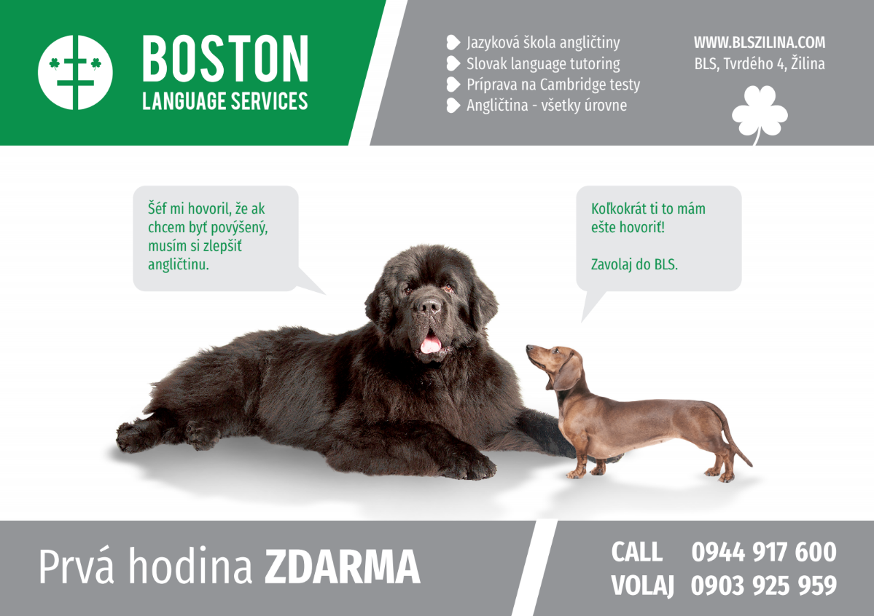

- NO CONTRACTS

- NO PAYING UPFRONT

- FLEXIBILITY

- NO HIDDEN EXTRA PAYMENTS

- CUSTOMIZED SERVICE

- OUR METHOD IS WORK

AGENDA BLS
- NO CONTRACTS
We don't want our clients to be bothered and tied up by committing or signing contracts, if they don't decide otherwise themselves or until they verify our services. We don't want to start our cooperation with stress.

- NO PAYING UPFRONT
It is uncomfortable for a client to pay in advance for the lessons which they might not want or be able to attend.

- FLEXIBILITY
We don't want our clients to be forced or limited by the time when and the place where the class takes place.

- NO HIDDEN EXTRA PAYMENTS
We don't think it's correct to bill clients for coffee or copies of a study material. We consider it silly, absurd, short-sighted and unprofessional.

- CUSTOMIZED SERVICE
We customize the lesson content according to your needs and your personality. We don't teach you what we want, but what you need and is contributive to you.

- OUR METHOD IS WORK
Even though it's not very popular and pleasant for our ears, we don't want to mislead our clients with a theory that they will learn the language thanks to a miraculous method. Besides, if anyone presents their methods to be 100% functional, they claim that one method is effective to every student. However, It's not very pedagogical thing to say. Every student is an individual, a particular method works for a particular student. We are able to analyze student's needs and customize the tuition. It's pleasant to hear that we don't have to do anything to achieve the progress, but it's immoral and greedy. We rather tell students the truth. We will have to study, but we'll use all the different and effective methods suitable directly for an individual.

